Reset your password

- How to reset password

Please ensure that you mobile number is updated. If you have forgotten your password, click on forgot password on the login page of email.gov.in. You will be redirected to PASS-APP or follow the URL https://passapp.emailgov.in/ . Using this application you can reset your password.
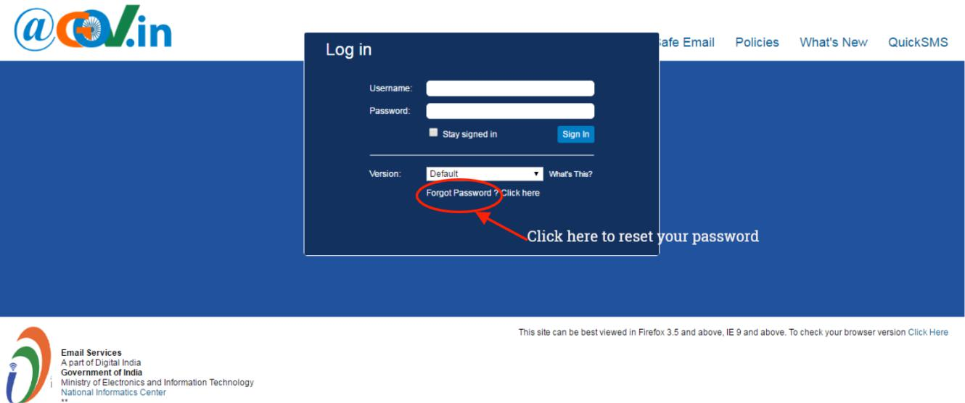

You will be redirected to PASS-APP to reset your password.
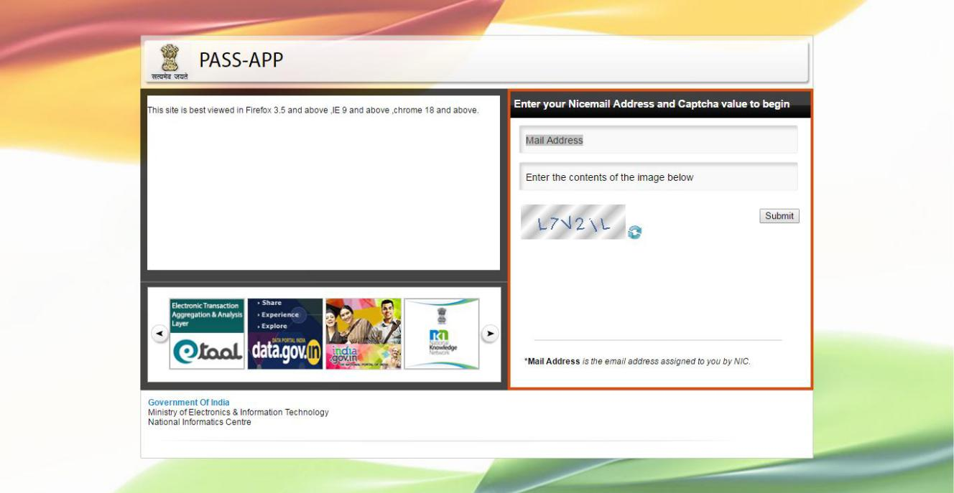

- Enter the email address for which you wish to reset your password.

- Also, enter the Captcha value as displayed in the box.

- Click on submit button to proceed further.
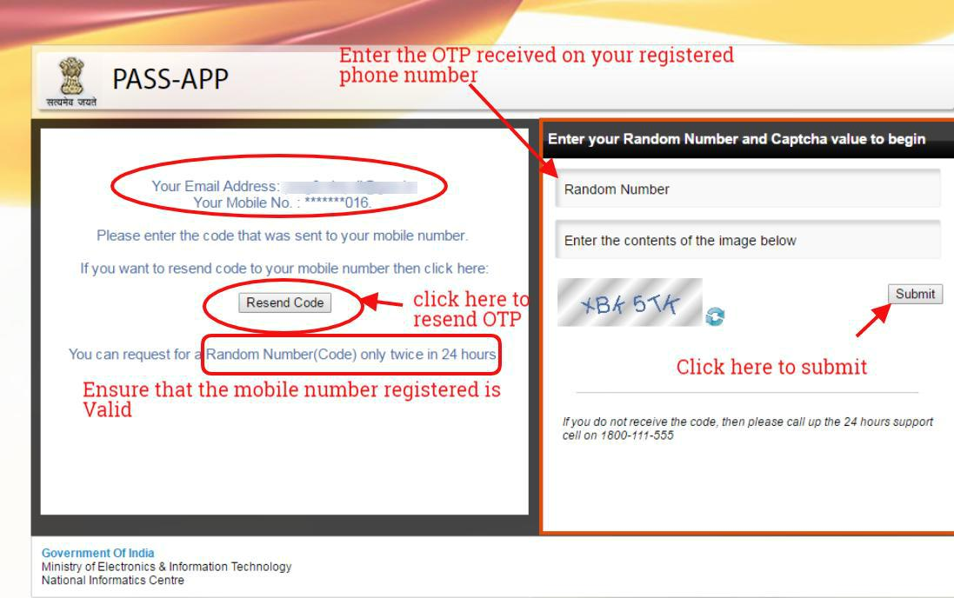

Enter the random number which is sent to your mobile number. You can also resend OTP if not received at once (** Random number will be generated twice in 24 hours)

Now, enter the Captcha value and confirm your submission.

Now you will be redirected to a page which will prompt you to enter your new password twice. Enter the Captcha value to confirm.

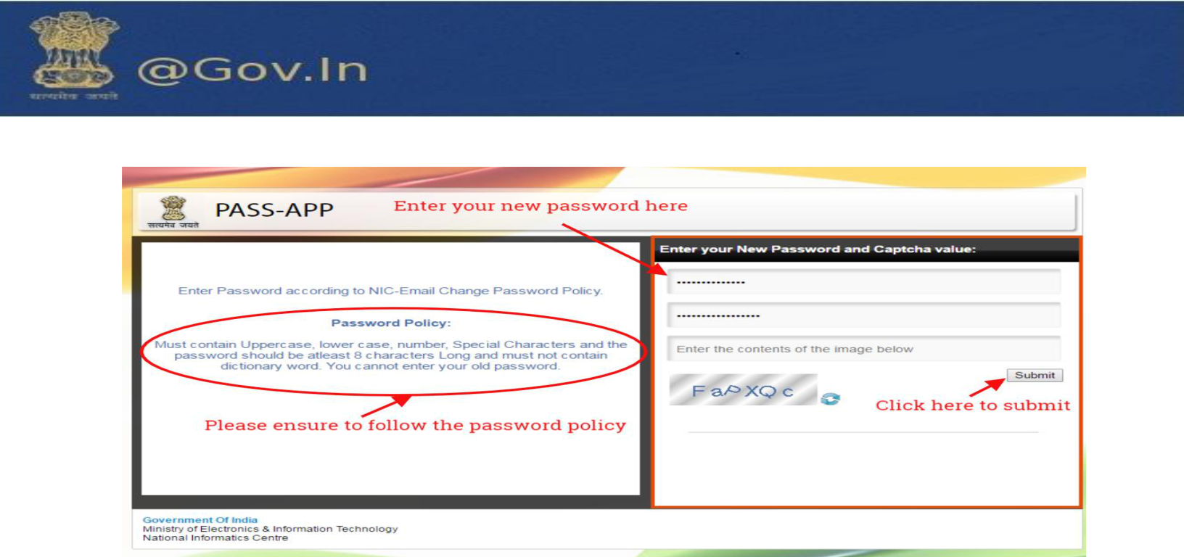
You must follow the password policy as prompted to reset your password.

